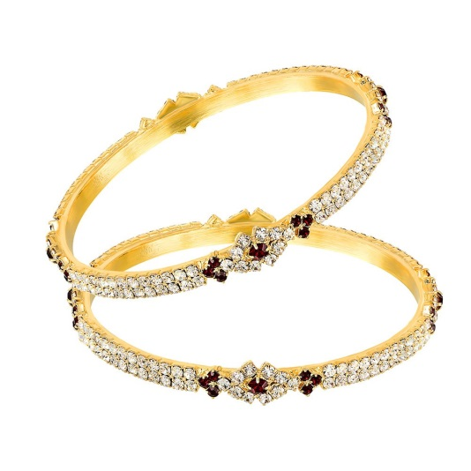

An exquisite and contemporary bracelet, meant to adorn those delicate wrists. This enticing piece crafted with meticulous attention will bring uniqueness to your outfit. Manufacturer: Mahi Fashion Jewellery Warranty: 6 Months Manufacturer Warranty

Product: MAHI

Price:4,024.00 PKR

CONTACT US: Address: Aptech Metro StarGate Karachi

Phone.no: 03142191402

Email: feedback@aptech-educationcom.pk